**LEVEL 2 QUESTIONS**

**Ch Rama Karthik Reddy CSA0805 python programming**

**1.To count all the prime numbers and composite numbers**

**Sample input: 4,54,29,71,59,98,23**

**Output: composite numbers=3**

**Prime numbers = 5**

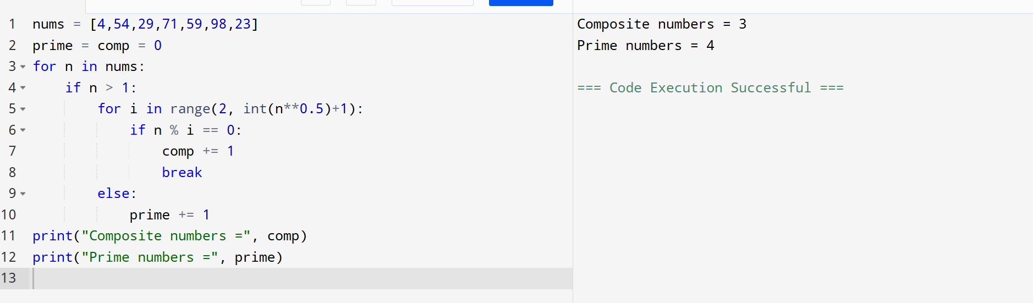

**2. Sum of daigonal matrix**

**Sample input: [1 2 3 4 5 6 7 8 9]**

**Output: diagonal elements are 1,5,9**

**Sum of diagonal elements=15**

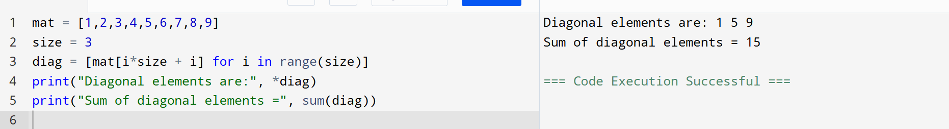

**3.Perfect number or not**

**Sample Input: 6**

**Output: it is a perfect number**

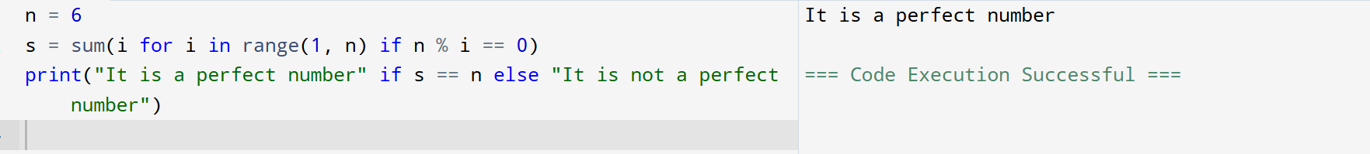

**4. Write a program in Python to read the elements of a one-dimensional array, compare the elements and find which are the largest two elements in a given array.**

**Sample Input:**

**1 2 3 4 5 6 7 Output:**

**Largest two elements : 6 & 7**

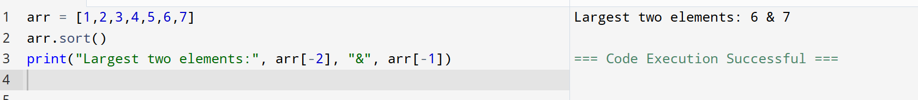

**5. Find the Mth maximum number and Nth minimum number in an array and find the sum and difference of it.**

**Sample Input:**

**Array of elements = {14, 16, 87, 36, 25, 89, 34}**

1. **= 1**
2. **= 3**

**Output:**

**1st Maximum Number = 89**

**3rd Minimum Number = 25**

**Sum = 114**

**Difference = 64**

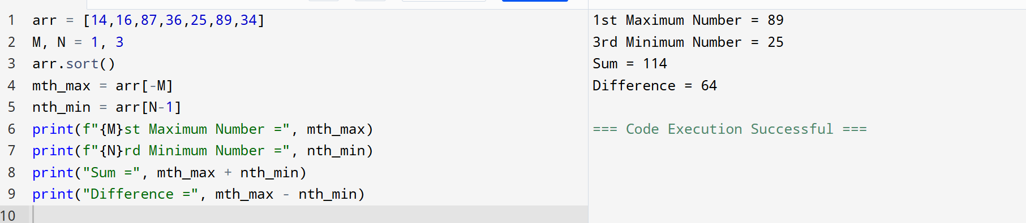

**6. Find GCD and LCM in Python**

**Sample Input & Output:**

**LCM of 15 and 20 is 60**

**The gcd of 60 and 48 is : 12**

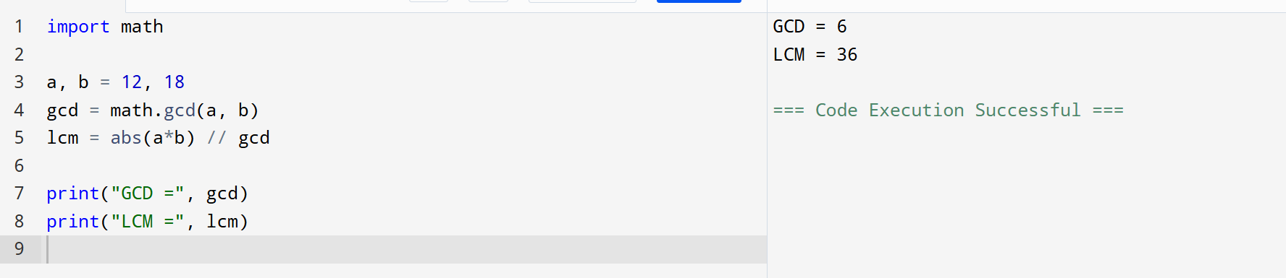

**7. Write a Python program to display customer name mobile number and cost of the purchase.calculate the discount and find the total amount to be paid.**

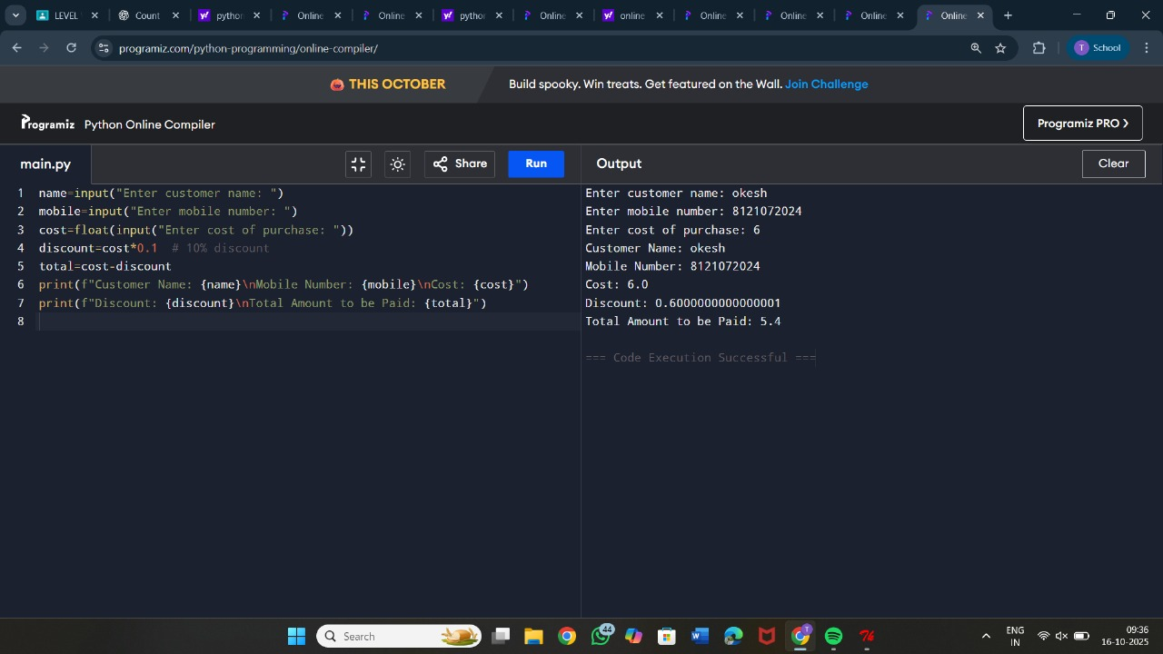

**8. Write a Python program to find largest 2nd maximum in array Sample Input: a={1,6,4,2} Output:4**

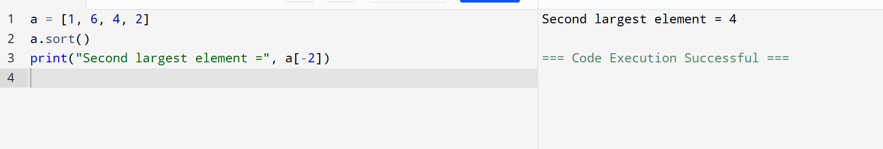

**9. You are give with an array which contains integer element. Sort the elements in non-increasing order and print the middle element of the array.**

**Sample Input: arr = {90,-90,80,66,78,10} Output:**

**{-90,10,66,78,80,90}**

**Mid-element:66**

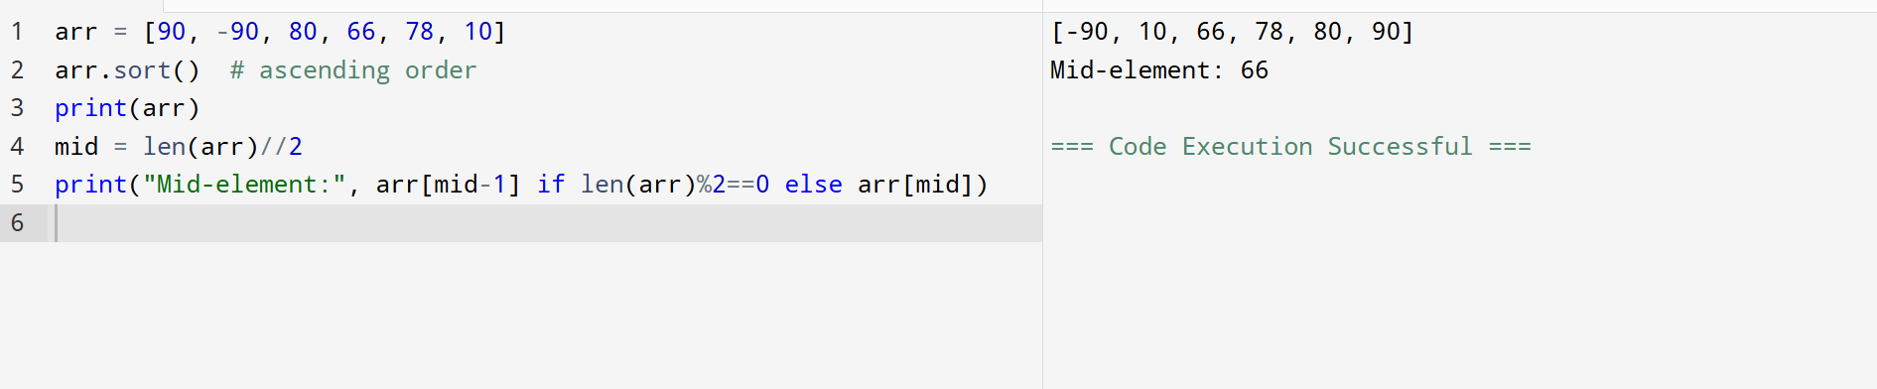

**10. Write a python program to print multiplication of 3 matrices.**

**First matrix elements:**

1. **1 1**
2. **2 2**
3. **3 3**

**Second matrix elements**

1. **1 1**
2. **2 2**
3. **3 3**

**Third matrix elements**

1. **1 1**
2. **2 2 3 3 3 multiplication of the matrix:**

**36 36 36**

